Paper title – Times New Roman, bold, 14, center

Name Surname¹, Name Surname²
¹ Name of Institution/Department, City, Country, e-mail
² Name of Institution/Department, City, Country, e-mail

Abstract
Leave one empty line under the author(s) and write the abstract – 250-500 words; Font: Times New Roman, Size: 11 pt, Font style: Regular, Alignment: Justify; Line spacing: Single; Special/First Line: 1 cm.
Keywords: After the abstract enter up to 5 keywords

Introduction
After the Keywords leave one empty line and start with a couple of sentences that introduce the topic.

1. Headline
Main text of the paper – Font: Times New Roman, Size: 12 pt; Line spacing: Single; Alignment: Justified, Special/First Line: 1 cm. Please note that the full paper should not exceed 8 pages including text, figures, tables and references.
Language: Papers should be written in English Language.
Font: Times New Roman, Size 12, Colour Black.
Page Setup: Size: A4 paper, Portrait.
Margins: Left/Right 2.5 cm, Top 2.5 cm, Bottom 2.5 cm, Header/Footer 1 cm.
Alignment: Justify, Line spacing: Single, Paragraph Before 0pt, After 0pt.

2. Headline
Harvard Referencing In-Text: In-text references must be included following the use of a quote or paraphrase taken from another piece of work. Using an example author M. Moullin, this takes the form: Moullin (2004, p. 189) states.. Or (Moullin, 2004, p. 189)
When citing a source with two or three authors, state all surnames like so: Kennerley and Neely (2003, p. 189) states… Or (Kennerley and Neely, 2003, p. 189).
Tables: Table number should be positioned above the table – Font: Times New Roman, Size: 12 pt; Alignment: Right; On a new line the table title – Font: Times New Roman, Size: 12 pt; Line spacing: Single, Alignment: Center.

Table 1. Font: Times New Roman, Size: 12 pt; Alignment: Right.
Table title – Font: Times New Roman, Size: 12 pt; Alignment: Center
№ | Column1 | Column2 | Column3
1
2
3

Figures and images: Should be inserted at the appropriate place within the text boundaries; the figure number and title should be positioned below the figures – Font: Times New Roman, Size: 12 pt; Line spacing: Single, Alignment: Center.
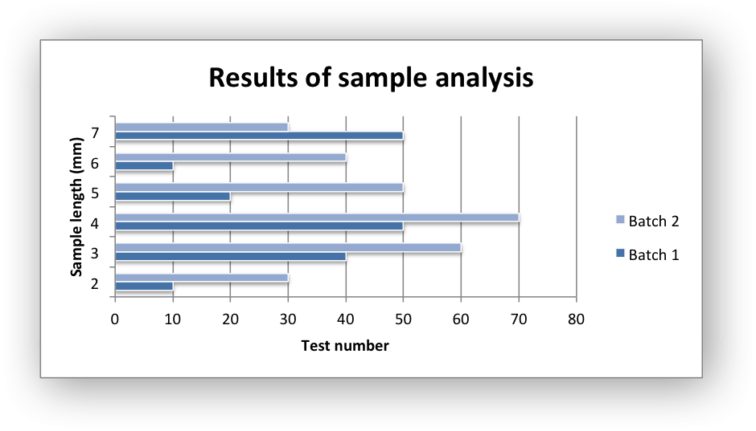
Figure 1. Font: Times New Roman, Size: 12 pt; Alignment: Center
Source: Own Elaboration / Adapted by (Author, year) / Created by (Author, year)

Equations: Number equations consecutively. Be sure that the symbols in your equation have been defined before or immediately following the equation.
$α + β=γ$   

Conclusion
Summarize the results of the research/paper and write the conclusion with a few sentences here.

References
- BRADBURY, I., BOYLE, J. and MORSE, A. (2002) Scientific Principle for Physical Geographers. Harlow: Prentice Hall.
- CAMPBELL, N. A et.al. (2008) Biology. 8th Ed. London: Pearson.
- KENNERLEY, M. and NEELY, A. (2003) Measuring performance in a changing business environment. International Journal of Operations and Production Management. 23 (2). pp. 213-229.
- MITCHELL, J., A. and Thomson, M. (2017) A guide to citation. 3rd Ed. London: London Publishing.
- MOULLIN, M. (2004) Eight essentials of performance management. International Journal of Health Care Quality Assurance. [Online] 17 (3). pp. 110-112. Available from: http://www.emeraldinsight.com/ [Accessed 2/03/2019].
- NEVILLE, C. (2010) The Complete Guide to Referencing and Avoiding Plagiarism. 2nd Ed. Maidenhead: Open University Press.

